**How to Install PuTTY on Linux**

[PuTTY](https://www.putty.org/) is a free and open-source cross-platform **SSH** and **telnet** client that even after being around for over 20 years remains one of the most popular SSH clients being used especially on the Windows platform.

**Read Also**: [Best Command-Line FTP Clients for Linux](https://www.tecmint.com/command-line-ftp-clients-for-linux/)

Linux distros ship with **SSH** capabilities built into their terminal but in real-world environments, I have seen **PuTTY** being used instead of the default Linux systems more time than I cared to count.

The quickest reasons that come to mind for such scenarios include:

* **Familiarity:** users are more comfortable using an SSH client they got familiar with while using Windows.
* **Debug mode:** Connection to serial pots and raw sockets is more user-friendly with PuTTY.
* **Convenience:** PuTTY has a GUI that undeniably makes it easier to use especially by SSH and/or terminal newbies.

It is possible for your own reasons for wanting to use **PuTTY** on GNU/Linux is different. It doesn’t really matter. Here are the steps to take in order to install **PuTTY** on Linux distro of your choice.

**How to Install PuTTY on Linux**

**PuTTY** is available to install from the default official repositories in most Linux distributions. For instance, you can install **PuTTY** on **Ubuntu** and its derivative distros via the universe repository.

**Install PuTTy on Ubuntu**

First, you’ll have to enable the universe repository so that you can access its packages, update your system to recognize its new access rights, and then run the install command.

$ sudo add-apt-repository universe

$ sudo apt update

$ sudo apt install putty

Launch **PuTTY** to see that its UI mirrors that of the windows version. Happy you :-)

[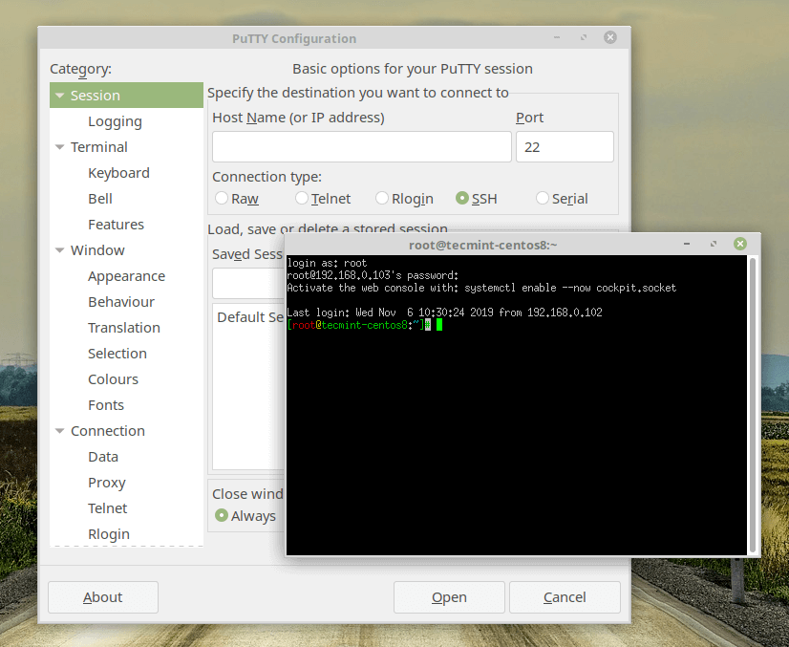](https://www.tecmint.com/wp-content/uploads/2019/12/Putty-on-Ubuntu.png)Putty on Ubuntu

**Install PuTTy on Debian**

Just like for **Ubuntu**, **PuTTY** is available for **Debian** and all its distros via [aptitude](https://www.tecmint.com/linux-package-management/) (i.e. using **apt-get**) as shown.

$ sudo apt-get install putty

**Install PuTTy on Arch Linux**

**Arch Linux** and its derivatives can also install **PuTTY** from the default repositories.

$ sudo pacman -S putty

**Install PuTTy on CentOS, Red Hat & Fedora**

**PuTTY** is available to install via the distro’s default package manager.

$ sudo yum install putty

OR

$ sudo dnf install putty

**Install PuTTy from Source Code in Linux**

It’s possible that you want to get your hands ‘**dirty**‘ and build the SSH client from scratch yourself. You’re in luck because it is open-source and the source code is available for free [here](https://www.chiark.greenend.org.uk/~sgtatham/putty/latest.html).

$ tar -xvf putty-0.73.tar.gz

$ cd putty-0.73/

$ ./configure

$ sudo make && sudo make install

That’s all folks! You’re now equipped with the knowledge to install **PuTTY** on any Linux distro, in any environment. Now learn how to use putty with this [useful putty tips and tricks](https://www.tecmint.com/putty-configuration-tips-and-tricks/).

Do you use a different SSH or telnet client? Tell us about it in the comments section below.